Vermot-Desroches Matthias

Rapport de séance n°8

During this session, I started by making new CAD models for the servomotor ensemble, mostly to have larger and longer pieces and the holes to fix the servomotor:

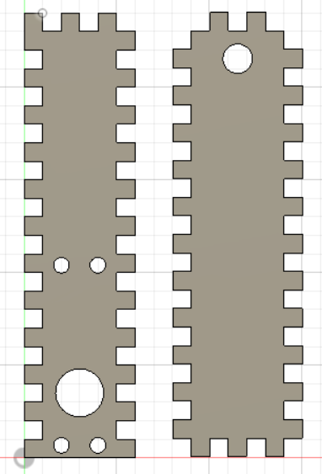

On the left side, you can see the piece on which the servomotor will be fixed. I will use four screws and the tightening of the pieces to fix it.  
On the right side, you can see the pieces that will be glued horizontally to the other piece, assuring the tightening of the servomotor. The hole at the top is here to let an axis go through and allowing the ensemble to rotate.

After that, I used the cutting machine to make the corner pieces for the wooden model. Here is a picture of them:

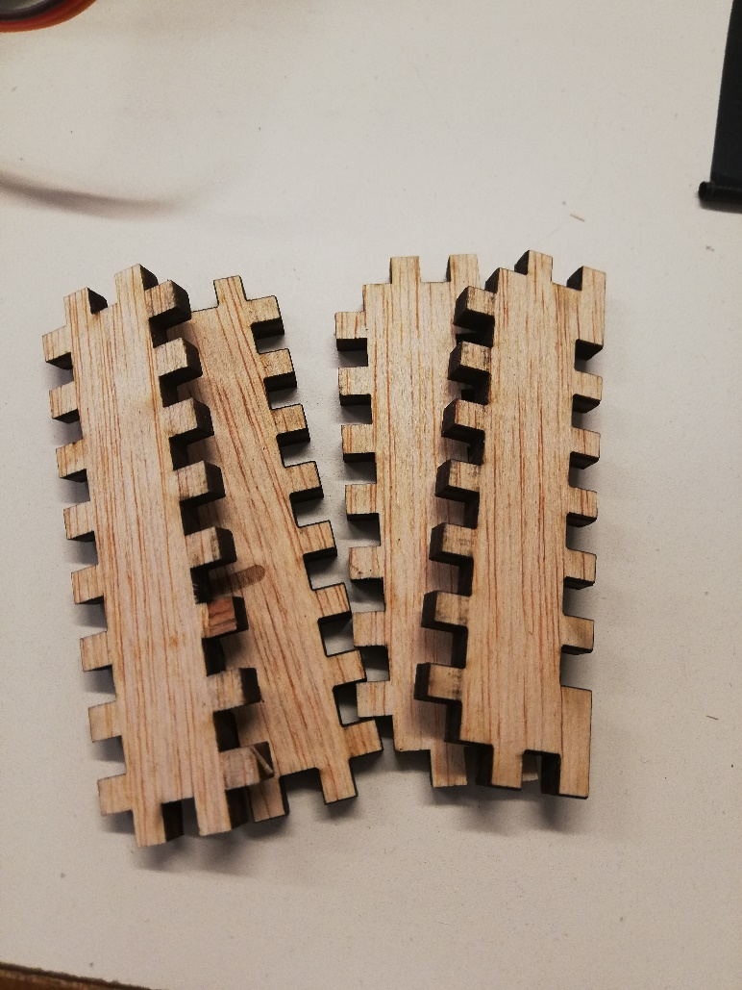

You can see the male corner pieces on the left and the female one on the right.

After making the first couple of corners, I tried to see if they fitted on the plate’s corner:

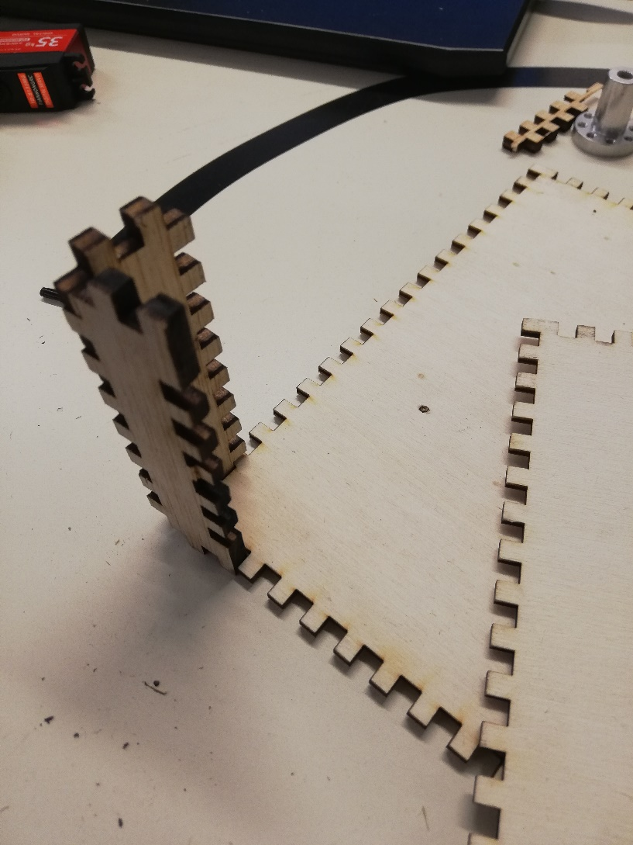

You can see that they indeed fitted, so I made the remaining pieces to have enough for four corners.

Then, I glued the corner pieces together, here is a picture:

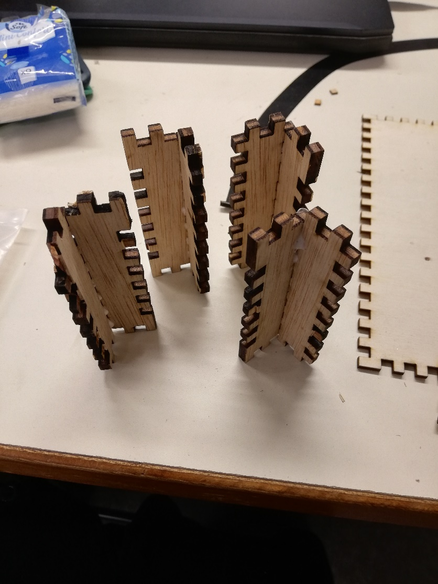

After that, I glued them to the wooden plate:

Now, the assembly of the wooden model is almost finished, the only things missing are the servomotor ensemble. Unfortunately, the cutting machine was reserved during the rest of the session, so I could only modify the CAD model or advance in the programming part.

After speaking with the professors, I decided to focus on the CAD model to have at least on ensemble made before the holidays. So, I modified the CAD model to incorporate the suspension because I forgot to take them in account.

Since the suspension will be put at a fixed height, we will considerate that they are not fully extended when fixated on the ensemble. That leaves us with the length between the plate and the servomotor.  
To determinate this, I chose a height of 50mm and a suspension’s length of 60mm (out of 70mm but it is probably the shortest it can be).

Here is how I determined the length:

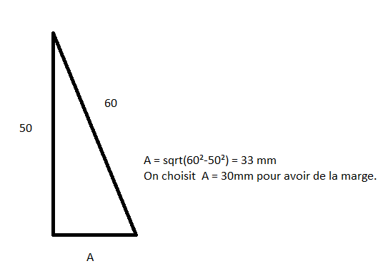

To finish this session, I modified the CAD model to have a length of 30mm between the plate and the servomotor. Here is how it looks:

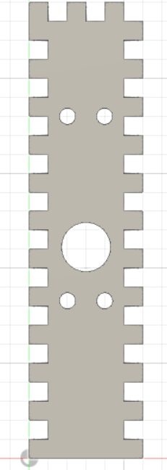

The holes made to fix the servomotor were drawn closer to the part that will be fixated on the assembly. As of now, I don’t know if I should still shortened the length of this model or leave it like that.